**Printf Scanf Assignment**

Q1. WAP with

**1a. function readdisplay() to read the following data types only one at a time at run time and to display.**

1. char type

2. integer type

3. char array of maximum 80 characters

4. short type

5. float type

TestData:

‘c’, 8978, “hello”, 8, 45.678

‘H’, 254, “hello Hi How”, 256, 145.2678

**1d.)** Add code to display the size of each data type mentioned in Q1a and sizeof the variables of each datatype (You may refer sample code in data_type_size.c )

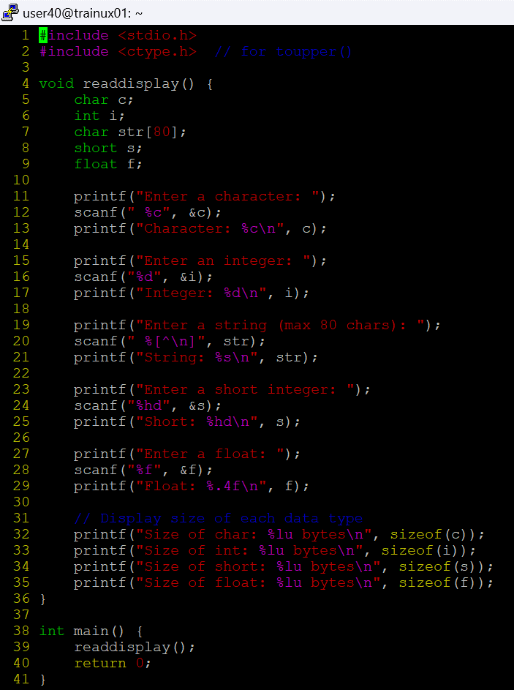

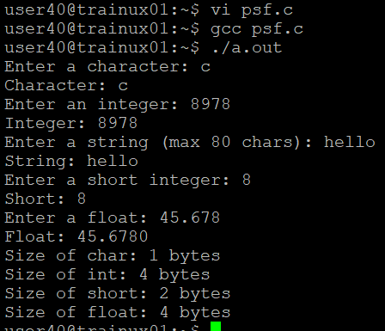

b. **Create a copy of readdisplay() as function readdisplay2() with changes below**

· Instead of reading 1 data at a time, read all inputs using a single scanf().

Test readdisplay2() by changing the read order. Do you observe any issue?

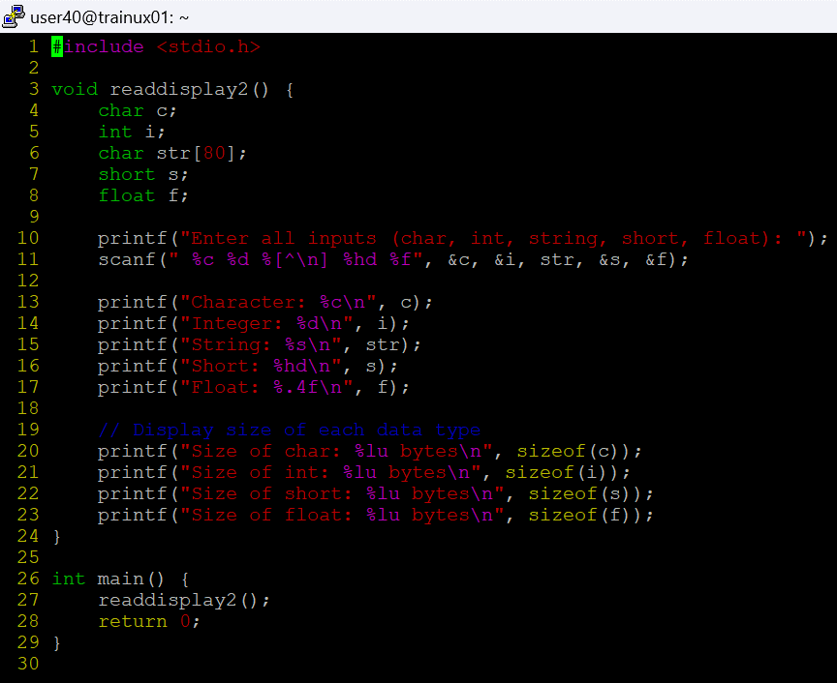

**1c. display the char array content in upper case**

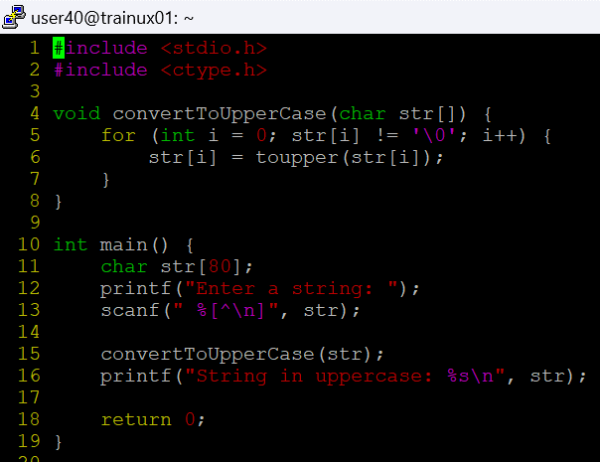

**Q2. Try to run the program with code snippet below. Check the output and analyse. Fix it to get correct result.**

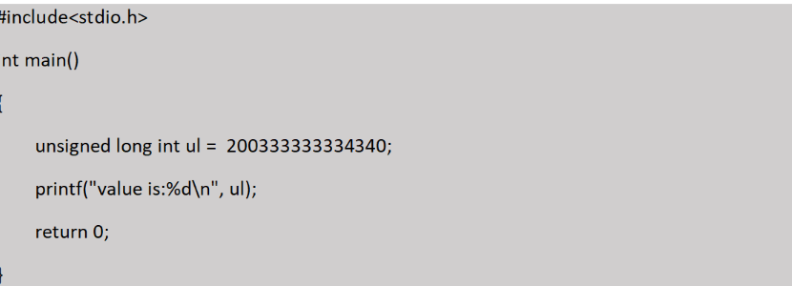

The issue in the provided code is related to the format specifier used for printing the value of an unsigned long int:

printf("value is:%d\n", ul);

Here, %d is used, which is a format specifier for a **signed integer** (specifically for int). However, ul is declared as an unsigned long int, and %d is not the correct specifier for this type.

